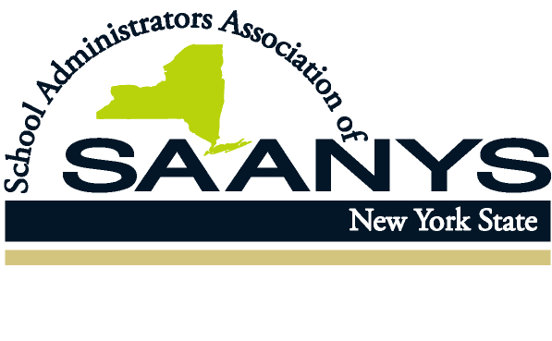
SAANYS Proposed 2021 Legislative Agenda
- Restore adjustments and/or deductions ($1.1 billion) made to state aid for the 2019-20 school year. Federal funding using the CARES Act was used to offset this reduction in state aid and did not fully restore the actual reduction in state aid. This “Pandemic Aid” blunted the impact of reduced state aid to districts but does not lessen the need for the state to provide adequate funding to schools.
- Ensure that the distribution of federal funding for education provides school districts direct aid to reimburse districts for all COVID-19 related costs, including transportation.
- Provide funding for professional development for building administrators and program leaders. Over the past year, the majority of support to teachers fell to building administrators, with little support for their own professional needs. This funding must be directed to entities that can deliver priority content directly to building-level administrators and program directors.
- Support legislation to increase the earnings cap for retirees should they return to public service. Retired administrators have been needed to support practicing building leaders and program directors during the pandemic. The current cap of $35,000 does not provide sufficient incentives for retirees to return to roles that are needed in schools.
- Increase the salary cap provision for determining retirement benefits.
- Support legislation to address inequities in digital access, with a focus on establish standards and equitable cost adjustments. Increase funding for the E-Rate program, which disseminates funds to districts for technology devices and services.
- Support legislation that continues to delink the use of mandatory assessments for determining evaluation ratings for principals, and redirect the purpose of the evaluations for teachers and principals to increased emphasis on achievement of district and professional goals.
- Provide flexibility for determining eligibility to graduate by expanding options for assessing achievement of state standards to include portfolios, regional/district assessments, and project-based performances.
- Decrease excessive mandatory accountability requirements placed on districts such as student participation as a measure of district performance and excessive district compliance plans.

