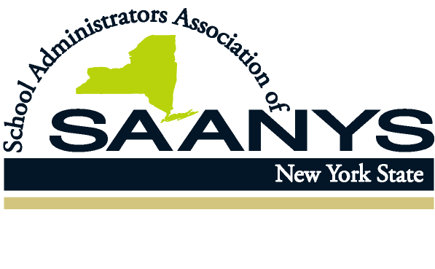
APPR ALERT AND UPDATE
DECEMBER 2020

This is an update to the October APPR update below:
New open timeframe for variance applications applicable to 2020-21

SAANYS is happy to report that variance applications for temporary modifications to APPR for this school year may now be submitted at any time during the year. This was something we had advocated for and was recommended by the Commissioner and passed by the Board of Regents at the meeting of 12/14/2020. Previous to this week, all variance applications for temporary changes to APPR plans for the current school year had to be submitted by December 1, 2020. As outlined below, SAANYS still believes that this process is the best way to handle evaluation changes now.

New resource materials, including an updated Principal APPR Agreement Template with Notes, a sample district-wide student performance metric, and a sample Input Model for the student performance category are available on the member section of the SAANYS website. Go to www.saanys.org -Resources – APPR.

Please feel free to contact us for additional information and guidance.

APPR UPDATE
OCTOBER 2020

There seems to be some thought that APPR plans must be renegotiated this year. That is not the case. While they can be renegotiated to be made consistent with the changes in law/regulation of 2019, it is not required. The same law/regulation indicates that all current, previously approved plans stay in place and must be implemented until there is a newly negotiated and approved plan. Unlike the original 3012-d legislation, there is no state aid implications related to negotiating new plans under the 2019 provisions.

SAANYS received recent clarification from the NYSED Office of Educator Quality and Professional Development regarding any desires to modify existing plans for teacher or principal evaluations for this year due to COVID or for other short-term needs. The department makes a distinction between a “material change” (permanent changes to any provision in the current approved plan in the portal) and a “variance” (short-term changes considered broadly as new and innovative).

If you submit any material changes, the whole plan must be revised to be in compliance with the changes in law/regulation of 2019 for both teacher and principal evaluations. This does not seem to be the year for districts to engage in extensive APPR negotiations with the two bargaining units representing teachers and principals.

However, if you submit a variance request, you just need to assure that the other aspects of your current previously approved plan will be implemented. Variances can be for any aspect of the approved plan if they are for one to three years, with indication that you will return to the provisions of the approved plan when the variance ends. The reason can be to adjust to the changing environment during the COVID period - or as a pilot to try a different approach. That could include piloting the "input model" for principals’ student achievement measures. If you meet the minimum requirements of statute and regulation, the variances will likely be granted. A simple MOA with the unit representing the employees impacted should suffice, assuming an agreement between the unit and the district.

One of the unique changes to APPR in the regulations of 2019 was to add an option for determining the student performance measure and rating for principals – an “input” model. Rather than using student test results, this model measures effectiveness based on actions of a principal to improve learning and achieve related goals. Scores and ratings come from a negotiated methodology to assess professional practice. The use of the 20-point conversion chart required to determine HEDI ratings for SLOs is not required. However, it comes with its own risks that are different than the careful use of student test results. The use of an input model can be done as a “pilot” for one to three years and, therefore, be submitted as a variance rather than a “material change” (permanent) to the current plan. Bargaining units should seek assistance in considering and designing any input model for this purpose.

Part of a variance application will be to assure that the variance will inform professional learning in the district. This can be as simple as copying related language from the district's annual professional learning plan - or a sentence or two indicating that the changes will still provide pertinent data on teacher and/or principal performance to help focus on appropriate professional learning. Variations are handled through the NYSED Business Portal for school districts but are separate from the APPR submission form for any material (permanent) changes. Applications for the variance application can be requested by the district in an email to APPRVariance@nysed.gov.

Remember, any agreement about changes to APPR, including variances, should be done through negotiations and a subsequent MOA, not just by signing off on a submission to the portal. While not recommended, if you are interested in negotiating material changes, we will assist with negotiations to assure full compliance with all APPR changes required by the law and regulations of 2019. We believe the prudent approach to any modifications needed this year is to use the variance option for temporary changes.

We hope this information helps but know that there may also be many questions or local needs to address. Feel free to contact Don Nickson at SAANYS (dnickson@saanys.org or (518) 782-0600, ext. 105) to discuss any current issues, desires, or questions regarding principal evaluation.

