Finger Lakes Resiliency Network

Being a Trauma-informed Organization
Frequently Asked Questions about partnering with FLRN

Why is being a trauma-informed organization important?

- Trauma and adversity are growing public health concerns that impact all.
- Using a trauma-informed approach in organizations is critical to the long-term success and well-being of an organization, its staff, and clients.
- Trauma-informed care can be seen as a universal precaution, similar to wearing gloves in the medical field, in that professionals approach all interactions as though everyone involved has a history of trauma and should approach all stakeholders as such in order to reduce the possibility of triggering or re-traumatizing others
- A trauma-informed entity not only recognizes the effect of trauma on clients/patients/students/consumers, but also the impact on the workforce based on their own and others’ experiences of trauma.

How can the FLRN help my organization become trauma-informed?

- The Finger Lakes Resiliency Network (FLRN) utilizes a three-phase trauma- informed learning community that provides consultation, training and support.
- With a focus on leadership buy-in, FLRN supports participating partners through a journey that combines a cumulative curriculum map delivered through workshops and organization-specific coaching sessions.
- The content is based on SAMHSA’s “Ten Domains of Implementation” which provide a foundation upon which the trauma-informed work is based and is further explained below.
- The action planning is based on the “Trauma-Informed Organizational Change Manual” from the School of Social Work at the University of Buffalo.
- Workshops are every other month with individual coaching sessions occurring opposite Workshop months.
  - We refer to the Workshops as “the WHAT,” as in, “What do I need to know to know in order to start this work?”
  - FLRN coach(es) walk agencies through “the HOW”, the three phases of moving organizational culture along the continuum from trauma aware to trauma-sensitive to healing-centered.
- True organizational change is not an event, but a process that can take three to five years, depending on the size and structure of the organization/system.
  - In lieu of a Checking the Boxes Approach which focuses on task completion, FLRN approaches this work as an ongoing process that results in a cultural shift
  - FLRN coaches work collaboratively with partners right from the beginning to develop fluency in trauma-informed language, construct an understanding of what being trauma-informed will look, sound, and feel like in their organizations.
- Determining when an agency is ready to move on to the next phase is a collaborative process between the Core Implementation Team (CIT) and the assigned FLRN coach(es).

How does an organization progress through this process?

3 Phases of Implementation (adapted from the ITTIC)

Phase I: Pre-Implementation (PI)
- FLRN partners are given tools to assess where their organization/system is along the trauma-informed continuum.
- From the start, our FLRN coaches act in a trauma-informed manner throughout all interactions, a strategy known as Modeling the Model.
- Additional support of this Phase is provided by ongoing “Trauma and ACEs” foundational training that is offered monthly and open to staff and leadership of participating FLRN agencies to support Workforce Development efforts.
Phase II: Implementation (I)
- Builds on Phase I objectives and overlays new objectives aimed at expanding key development area within the Ten Domains of Implementation (SAMHSA) and expanding the Trauma-Informed Action Plan (“road map”).
- Often in this Phase, forward momentum (and thus, enthusiasm) increases as agencies first focus on easily obtainable action steps that continue to weave the trauma-informed approach into the fabric (operations) and culture of the organization.
Phase III: Sustainability (S)
- The foundation created in Phase I combined with the framework constructed through guided practice and implementation of Phase II., prepares FLRN Partners for Phase III., which focuses on sustainability of a trauma-informed approach
- Organizations dig deep into policy and practice changes, implementation of evidenced-based practices, expanded consumer and peer support roles, and expanded partnerships providing community-wide impact.
- Progress monitoring and quality assurance using agency-specific data is one of example of how this final Phase prepares partners to sustain and continue to grow their commitments to a sustainable trauma-informed approach as a part of a larger network and system of care.
- This is when the shift from “trauma-informed care” to “healing centered engagement” occurs.

What Principles/Values guide this work?

6 Core Values of FLRN (adapted from SAMHSA)

- Safety:
  - All stakeholders feel physically and psychologically safe
  - Physical setting is safe and interpersonal interactions promote a sense of safety.
  - Safety as defined by those served is a high priority.
- Trustworthiness:
  - Organizational operations/decisions are conducted with transparency
  - Goal of building and maintaining trust with all involved in the organization.
- Support:
  - Peer (aka trauma survivors) support and mutual self-help are key vehicles for establishing safety and hope, building trust, enhancing collaboration, and utilizing their stories and lived experience to promote recovery and healing.
- Collaboration:
  - Importance is placed on partnering and the leveling of power differences between staff and clients and among organizational staff
  - Healing happens in relationships and in the meaningful sharing of power and decision-making.
  - The organization recognizes that everyone has a role to play in a trauma-informed approach.
- Empowerment:
  - Throughout the organization individuals’ strengths and experiences are recognized and built upon.
  - Organization fosters a belief in the primacy of the people served, in resilience, and in the ability of individuals, organizations, and communities to heal and promote recovery from trauma.
  - Clients are supported in shared decision-making, choice, and goal setting to determine the plan of action they need to heal and move forward.
  - Staff are facilitators of recovery rather than controllers of recovery.
- Equity:
  - The organization actively moves past cultural stereotypes and biases
  - Offers access to gender responsive services
  - Incorporates policies, protocols, and processes that are responsive to the racial, ethnic and cultural needs of individuals served
  - Recognizes and addresses historical trauma.

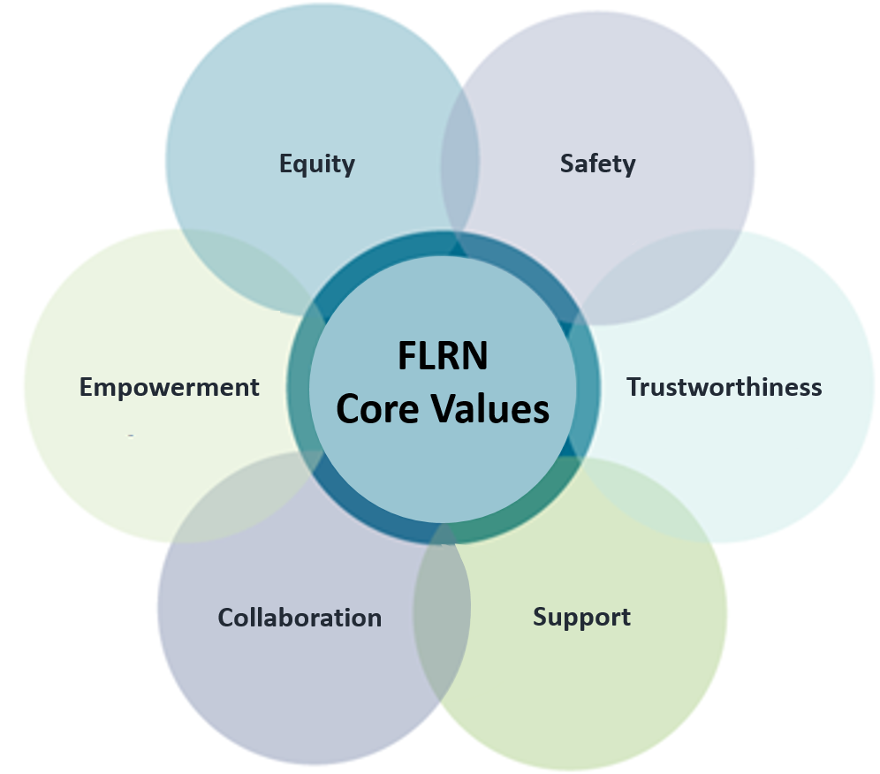

What is this curriculum based on?

Based on SAMHSA’s Domains of Consideration

- Governance & Leadership- leadership supports and invests in implementing and sustaining a trauma-informed approach.
- Policy- written policies establish the trauma-informed approach as a key part of the organizational mission
- Physical Environment- Everyone experiences the setting as inviting, collaborative and physically/emotionally safe.
- Engagement & Involvement- all stakeholders in the organization have significant involvement and voice in all areas of organizational functioning.
- Cross Sector Collaboration- collaboration with others is built on mutual understanding of trauma and the guiding values and principles of a trauma-informed approach.
- Screening, Assessment, & Treatment Services- All practices/services of the organization/system reflect the 6 Principles of a trauma-informed approach.
- Training & Workforce Development- organization believes that ongoing training on trauma, a trauma-informed approach and self-care are essential
- Progress Monitoring & Quality Assurance- organization has ongoing assessment, tracking and monitoring of the guiding 6 Principles of a trauma-informed approach.
- Financing- financial structures are in place to support resources needed for implementation and sustainability of a trauma-informed approach.
- Evaluation- Evaluations of implementation and service provision reflect an understanding of trauma and a trauma-informed approach

What is the philosophical goal of membership in the FLRN?

Progressing through the 3 Levels of a Trauma-Informed Approach (adapted from ITTIC)

- Trauma-Informed: Organization is aware of the prevalence and impact of trauma and engages in universal precaution for re-traumatization by anchoring in the 6 guiding values (see above)

- Trauma Sensitive: Organization deliberately looks at all levels of operation/functioning to respond to others in a way that is sensitive to potential trauma histories

- Healing-Centered: Organization offers evidence-based, trauma treatments/interventions specifically designed to treat and help individuals heal from trauma

