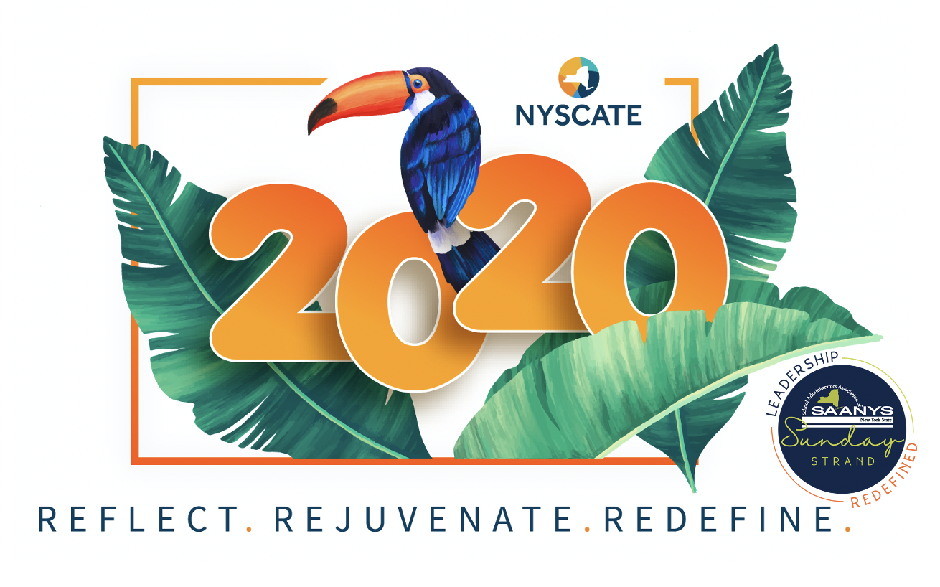
2020 SAANYS / NYSCATE
Annual Conference Registration Form

First Name __________________________ Last Name___________________________________

Phone__________________________ Email_______________________________________

Home Address__________________________________________________________________

City___________________________________________ State____________ Zip____________

District/BOCES ______________________________________ Job Title: ______________________________

Work Address__________________________________________ Work Phone________________________

City _________________________________ State_____________ Zip___________

Checks and Purchase Orders should be mailed to:
SAANYS, 8 Airport Park Blvd., Latham, NY 12110 | Ph: 518-782-0600 | FAX: 518-782-9552 | EMAIL: cfoglia@saanys.org

Please make checks payable to: School Administrators Association of New York State

 | VIRTUAL CONFERENCE REGISTRATION |  |  |  | ADD ON CERTIFICATIONS
 | Full Four-day Conference |  | $155 |  | ISTE Certification 11/7, 11/14 & 11/28 9am-noon | $675
 | Single Day - Saturday |  | $99 |  | Microsoft MIE Trainer Academy 11/7 & 11/14 9am-3pm | $175
 | Single Day - SAANYS SUNDAY! (incl. all SAANYS & NYSCATE Sunday sessions) |  | $99 |  | Classcraft Certified Trainer 11/7 & 11/14 9am-3pm | $99
 | Single Day - Monday |  | $99 |  | Makey Makey Literacy Certification 11/7 9am-3pm | $149
 | Single Day - Tuesday |  | $99 |  | Google Trainer 11/7 9am-3pm | $129
 | Pre-Service Student |  | $75 |  | Minecraft EDU 11/14 9am-3pm | $79
 | Presenter or Other w/ Coupon Code _____________ (enter code).  Contact cfoglia@saanys.org for Code. |  | -0- |  | Get Certified with NearPod 11/14 9am-3pm | $79
*(if you are presenting, you must obtain a code for registration. Please contact Christine Foglia at cfoglia@saanys.org and request your code). If no code is provided, you will be billed at the full-conference rate. Also contact Christine with general registration questions.

GRAND TOTAL: _________________________

