Hybrid School Schedules: More Flexibility; Big Logistical Challenges

Students walk into a classroom while keeping their distance as their teacher, Danielle Elliot, waits outside at Chase Avenue School in El Cajon, Calif.
—Ariana Drehsler for Education Week
By Denisa R. Superville
June 24, 2020
Opening school with a mix of online and face-to-face instruction—the so-called hybrid model—is shaping up to be the most likely option for scheduling this fall.
A hybrid schedule can take many forms. It offers schools the most flexibility but does carry risk by putting people inside buildings together, even if it’s in smaller groups and with social distancing protocols. The logistics will not be simple. And the learning curves for everyone will be steep.
Limited in-person instruction gives districts a chance to at least restart daily, in-school classes for their most vulnerable students, including those in special education, low-income students, English-language learners, or younger students, who generally had more difficulty with remote learning than secondary school students.
School districts can customize hybrid schedules to meet their needs and address specific weaknesses highlighted by research, their own experiences, and student and parent feedback.

District and school leaders are confronting difficult, high-stakes decisions as they plan for how to reopen schools amid a global pandemic. Through eight installments, Education Week journalists explore the big challenges education leaders must address, including running a socially distanced school, rethinking how to get students to and from school, and making up for learning losses. We present a broad spectrum of options endorsed by public health officials, explain strategies that some districts will adopt, and provide estimated costs.

Part 1: The Socially Distanced School Day Part 2: Scheduling the COVID-19 School Year
And by organizing face-to-face instruction—whether it’s every day, most days, or on a rotation—around smaller cohorts of students, schools can more easily overcome two of the biggest hurdles to reopening: adhering to social distancing protocols in classrooms and on buses.
“Flexibility and agility are personality characteristics that we have to have—and organizations have to be flexible and agile right now—because if you are not, you are not going to survive this year, and kids are going to struggle,” said Scott Muri, the superintendent of the Ector County Independent School District in Odessa, Texas.
Still, hybrid models have a host of built-in challenges, including revising master schedules, ensuring there are enough teachers to handle multiple sections of the same classes, and figuring out new bus schedules. Some of the adaptations will be costly, and workloads may be heavy, especially for teachers. Continuity of instruction—between in-person and remote learning—will be a challenge.
Sharon Contreras, the superintendent of Guilford County Schools in Greensboro, N.C., said many of the hybrid models do not solve the equity challenges that were so stark when schools shut down in the spring and started distance learning.
But the schedules that allow students to spend as much time in school as possible hold the most promise.
“My biggest concern with any of these schedules is that students have already experienced a significant loss of instruction, which translates to a great loss of learning, particularly for poor students in the district, your most vulnerable,” Contreras said. “What keeps me up at night is the thought that we are not preparing students for life after Guilford County Schools. So, for younger students: Are they missing out on a sure foundation? For older students: Are they missing prerequisite skills for college, for careers? Are they missing coursework? It’s deeply troubling.”
But she also sees opportunities amid the difficulties.
“I do like that we are providing more options for students,” she said. “We do have to rethink education as just providing one model for students. It’s not optimal, nor will it serve them all well.”
Here are four hybrid schedule options school districts may consider with some pros and cons of each. Elements of each option could be intermingled to create more variations.

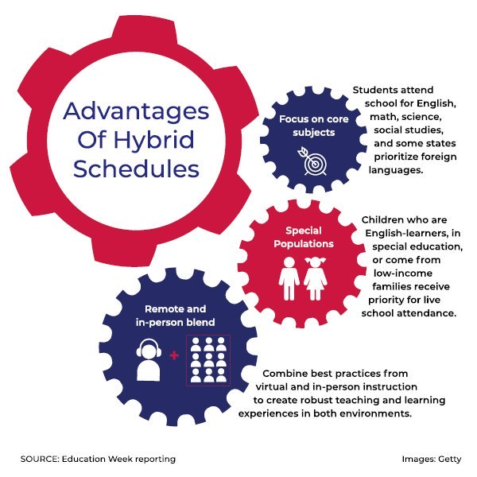

Option 1: In-Person Attendance for Students With Specialized Needs

What it looks like: In-person instruction and other services will be provided to children in special education, students who are English-learners, those who are low-income, or those who are vulnerable, such as students who are homeless or in foster care.
Full-time remote learning will continue for all other students.
During the spring shutdown of buildings, schools struggled most to serve these learners, which is why some superintendents and education experts say in-person instruction should be offered to them first.
“It’s all about equity—making sure that the kids that fall into those subgroups have the time and attention they need,” Muri said.
The 72,000-student Guilford County district provided daily face-to-face instruction for about 2,000 homeless and foster students at day-care centers that stayed open for the children of first-responders. While there was a high opt-out because of health concerns and parents’ fears that they’d lose their place in homeless shelters if they left during the shutdown, Contreras, the superintendent, plans to offer similar daily in-person instruction for students in transition next school year if the district opts for a hybrid model or remote learning.
Pros:
- The numbers of students and staff members inside buildings are limited, making it easier to comply with social distancing practices.
- Students most in need of academic and special supports receive them in face-to-face interactions.
Cons:
- Some risk of exposure and transmission of the virus.
- Working parents of students who continue with remote learning may object to their children missing out on in-person attendance and find it incompatible with their work schedules.
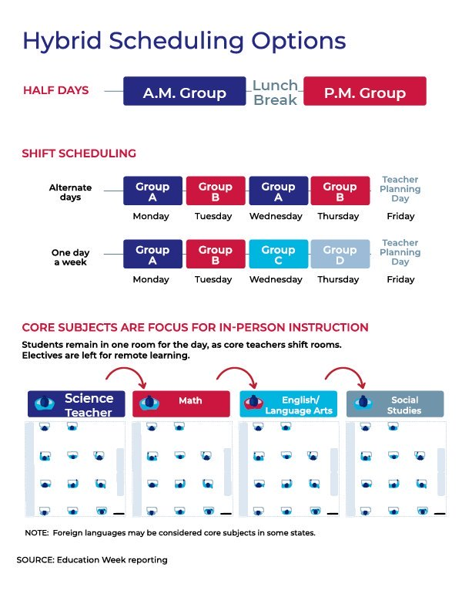

Option 2: Core Subjects Only for In-Person Sessions
What it looks like: All students attend school for core courses—math, English, science, history/social studies, and foreign language, in some cases. Electives are taken online.
Many states dispensed with the requirement that districts have at least 180 days of instruction when school buildings had to shut down in the spring.
L. Oliver Robinson, the superintendent of the Shenendehowa school district in upstate New York, said districts will need that same kind of freedom to make curriculum changes this this fall.
Without that level of flexibility, districts will be forced to try to fit a traditional calendar into a structure that might not be well-suited for it.
“It forces us to try to basically mimic the traditional schedule into an untraditional model instead of truly looking at alternative ways to provide education,” Robinson said. “We have to prioritize, and prioritization is focusing first on those core content areas, trying to structure how to deliver those in a hybrid model, and then trying to see what enrichment opportunities we can provide to families.”
Pros:
- All students receive face-to-face instruction for the main subjects.
- Children get regular interactions with their peers and their teachers.
- More compatible with parents’ work schedules.
Cons:
- Some risk of exposure and transmission of the virus.
- Adhering to social distancing practices is more difficult with students and staff in the buildings.
- Elective courses—which often tap most into students’ interests and passions and help with engagement—remain online.

Option 3: Elementary School In-Person, Middle and High School Remote
What it looks like: Elementary students receive in-person instruction, while high school students continue to learn remotely.
In one example from the Mississippi education department, elementary students attend school four days a week, allowing a district to use all its buildings for teaching to comply with social distancing guidelines.
High school students remain home and receive instruction online.
This is most likely a temporary option that can end when local health officials say it’s safe to relax some social distancing guidelines. Districts will then be able to phase in high schoolers.
Pros:
- Allows schools to restart in-person learning with a smaller number of students, spreading them out across buildings and making social distancing on buses easier to achieve.
- Prioritizes younger students who generally need more support for learning than older students.
Cons:
- Some risk of exposure and transmission of the virus.
- Middle and high school students miss out, at least initially, on a more robust, in-person learning experience.
- May be incompatible with parents’ work schedules, especially if they have children at different grade levels.

Option 4: Split Schedule AM/PM
What it would look like: Students are divided into two groups—one group attends school in the morning, the other group comes in the afternoon.
Students take classes online during the periods that they are not in school.
Those in the morning shift take lunch to go, while those arriving in the afternoon eat lunch at their desks before they start class.
Electives are held online or on Saturdays in person. Physical education can be taught in person or online.
Pros:
- All students receive daily, in-person instruction.
- Smaller groups of students make it easier for schools to adhere to social distancing protocols in buildings and on buses.
Cons:
- Some risk of exposure and transmission of the virus.
- Working parents will need alternative child-care during parts of the day when children are engaged in remote learning.
- Logistically challenging to align schedules for families with children at different grade levels and in different schools.
- Managing the master schedule will be a herculean task, especially at the high school level.
- May require renegotiating collective bargaining agreements with teacher and other employee unions.
- Multiple bus runs to drop off and pick up students at irregular times could be difficult, especially the need to disinfect buses during the quick turnaround.
- Requires cleaning and disinfecting between morning and afternoon shifts.
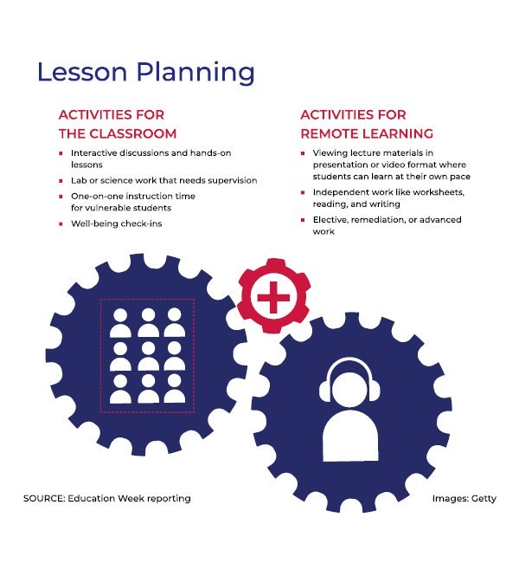

How to make hybrid schedules work:
Curriculum & Grading—Courses taught online need high-quality curricula, must be aligned to state standards, and must be accessible to English-language learners and special education students.
Grading policies must be updated to reflect the online components, and districts must also ensure that teachers work together so that there’s alignment between grades.
Teachers— In some cases, districts will have to work with the teachers’ union to make changes to the school day. In some states, a minimum number of hours count as a full day, and that will affect how long students can stay in buildings during each shift for districts that choose the split-schedule format.
Revise teaching schedules. Some in-person class periods may need to be extended, while others may need to be truncated. Teachers may need guidance on how to best use the face time they have with students.
Adopt flipped classroom models where students spend some time watching instructional videos before class. That helps reserve face time for student collaboration, student support, and hands-on work. In science classes, for example, students can complete prep-work and investigations either independently or with their peers online before their in-person lab assignments.
Clearly outline and communicate to teachers their new roles and responsibilities, along with expectations for fulfilling those. Some may need professional development on time management and flipped classroom strategies.
Hybrid formats may require more teachers in order to succeed. That could mean hiring additional teachers or increasing the substitute pool to help teachers with the workload.
The Guilford County district is formulating creative ways to use its current teachers and staff in a hybrid schedule.
District leaders there are considering buying Swivl technology, which will allow them to increase the number of students the district’s 5,000 or so teachers can teach at the same time. A teacher using Swivl can teach a small group of students in one classroom, while the lesson is projected into additional rooms. Those rooms can be staffed by aides, including about 200 who already work in the district’s after-school programs, Contreras said. The aides will offer adult supervision and assistance to students.
Tapping into AmeriCorps volunteers to help fill new staffing demands is another option the district is exploring, along with hiring recent graduates and retired teachers.
Provide adequate IT support to help teachers troubleshoot technology hiccups.
Students— Offer virtual orientation for students and parents so they understand how their hybrid school days will work.
Provide easy-to-access IT support for students when they are learning from home.
Conduct early assessments to determine where students are academically. The months-long remote learning period affected students differently, so an incoming 5th grader may not necessarily be at the same place academically as last year’s 5th graders. Teachers must be ready to build in support for students who are behind.
Plan carefully for the needs of the most vulnerable students. Those in special education may need full-time support, and small group sessions may be necessary during both online and in-person instruction.
Consider increasing the number of IEP meetings for special education students and holding regular meetings with families of English-language learners.
Operations—Develop new bus schedules. Make sure there are enough buses for more routes and for picking up and dropping off students at irregular times.
If possible, provide child-care for teachers and parents, who will need safe and supervised options for when their children are not in school.
Plan for and provide adequate protective gear for staff and students, post signs to remind everyone to follow social distancing rules, and follow local health guidelines.
Sources, in alphabetical order: Brett Blechschmidt, chief financial officer, Vancouver Public Schools, Vancouver, Wash.; Sharon Contreras, superintendent, Guilford County Schools, Greensboro, N.C.; Daniel Domenech, executive director of AASA, the School Superintendents Association; Eric S. Gordon, CEO, Cleveland Metropolitan School District, Cleveland, Ohio; Todd Horenstein, assistant superintendent for administrative services, Vancouver Public Schools, Vancouver, Wash.; David G. Hornak, executive director, National Association for Year-Round Education (NAYRE) and superintendent, Holt Public Schools, Holt, Mich.; Mike Magee, CEO, Chiefs for Change; Scott Muri, superintendent, Ector County Independent School District, Odessa, Texas; L. Oliver Robinson, superintendent, Shenendehowa Central School District, Clifton Park, N.Y.; Mike Stromme, deputy superintendent of teaching and learning, Vancouver Public Schools, Vancouver, Wash.; Steven Webb, superintendent, Vancouver Public Schools, Vancouver, Wash.; Robert Zywicki, superintendent, Mount Olive Township School District, Mount Olive, N.J.
Documents: “Rising to the Challenge of Covid-19: A Planning Framework for the 2020-21 School Year,” (May 2020), Los Angeles County Office of Education; “Reentry to a New Normal,” (June 2020), Mount Olive Township School District; “Maryland Together: Maryland’s Recovery Plan for Education,” (May 2020) Maryland Department of Education; “Covid-19 Considerations for Reopening Schools: Initial Guidance for Schools and Districts (May 2020) Kentucky Department of Education; “Considerations for Reopening Mississippi Schools,” (June 2020) Mississippi Department of Education; “Scheduling Concepts for Hybrid Learning,” Aaron Dover, Los Angeles County Office of Education; “Considerations for Schools,” (May 2020) U.S. Centers For Disease Control and Prevention; “A Strong and Healthy Start: Safety and Health Guidance for Reopening Schools,” (June 2020) Vermont Education Agency and Vermont Department of Health; “A Guidebook for the Safe Reopening of California's Public Schools,” (June 2020) California Department of Education

